John Rosatti christens the Mega Yacht Remember When
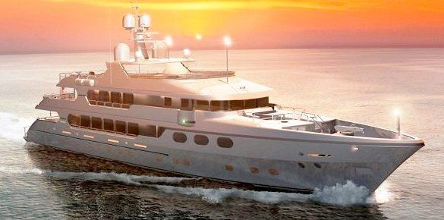

(1888PressRelease) Christensen Shipyards, the nation's premier luxury yacht builder, is proud to announce the christening of the M/Y Remember When.
(1888PressRelease) - Vancouver, WA - John Rosatti christened his new 162 Mega Yacht "Remember When", built by Christensen Shipyards, at this year's Showboats International Boys & Girls Clubs Rendezvous. The 23rd Annual three-day event hosts one of the largest gatherings of superyachts in the U.S. from Nov. 11-13, 2010 at the magnificent Rybovich Yacht Club in Palm Beach, FL.
The Christening of the M/Y Remember When, sponsored by Christensen Shipyards, began with a short ceremony on Thursday where Wanye Huizenga Jr. blessed the yacht with a story followed by a prayer. John's children Angela, Crystal and Adam, then splashed the bow deck with Champagne. Concluding this memorable occasion was a spectacular display of Fireworks.
John Rosatti launched his newest Mega Yacht earlier this year from the Christensen shipyard located in Vancouver, Washington. Taking three months off and traveling 5,500 miles, John Rosatti and family traveled the west coast through the Panama Canal to Florida where "Remember When" then debuted at the 2010 Fort Lauderdale Boat Show, before traveling up to West Palm for the rendezvous.
The new Christensen Mega Yacht, "Remember When features an interior designed by Carol Williamson and Associates. The yacht has 6 spacious cabins, including the Owners Cabin, VIP cabin, and 4 guest cabins which allow for up to 12 guests; interior woodwork has been done in high-gloss Black Walnut, with custom stonework throughout by Christensen Shipyards, In-House marble shop. The yacht's exterior styling was also done in-house by Christensen's naval architects, and features a raised forward bulwarks, vertical pilothouse windows, an extended sundeck and swimdeck. Powered by twin MTU 12V 4000 series engines. The vessel is controlled with an Ocean Yachts Systems (OYS) / Navis maneuvering and control system. Remember When is fully classified & certified to ABS (Maltese Cross) A1-AMS & MCA Unlimited Cruising.
ABOUT CHRISTENSEN SHIPYARDS:
The Christensen Shipyard is located in the beautiful Northwestern U.S., in Vancouver, Washington. It consists of over 180,000 square feet of climate controlled manufacturing space and a seven-acre marina. Its state of the art facility is key to the ability to adhere to high manufacturing standards and building yachts of unyielding quality and beauty.
If you'd like more information about this yacht, contact Christensen Shipyards at 360-695-3238
sales ( @ ) christensenyachts dot com
Other John Rosatti Blogs
http://www.rosattiyachts.com/
http://www.john-rosatti.com/
Trackback URL:
http://www.1888pressrelease.com/john-rosatti/rosatti-john/john-rosatti-christens-the-mega-yacht-remember-when-pr-260931.html
###

