Discovery Benefits Inc. Recognized for Outstanding Achievements
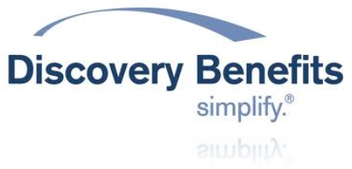
(1888PressRelease) Discovery Benefits Inc "We take pride in knowing that our administrative platform provides leading-edge technology unsurpassed in the industry. This allows us to provide a high level of customer service in an efficient manner for our clients.
(1888PressRelease) July 22, 2010 - Discovery Benefits Inc. Earns Partner Excellence Award for Evangelism
Fargo, ND - June 15th, 2010 - Discovery Benefits Inc. was recently honored by Lighthouse1 with a 2010 Excellence Award for outstanding business achievements. Discovery Benefits Inc. received the Excellence Award for Evangelism at Partner Conference 2010, the annual Lighthouse1 partner conference held recently in Minneapolis.
Discovery Benefits Inc. was selected for the award because of its strong commitment to and evangelism of the Lighthouse1 solution. Discovery Benefits Inc. has been active in sharing its experiences with the Lighthouse1 platform as well as providing ongoing feedback to help improve future product releases.
"We take pride in knowing that our administrative platform provides leading-edge technology unsurpassed in the industry. This allows us to provide a high level of customer service in an efficient manner for our clients," says John Biwer, President of Discovery Benefits.
The Excellence Awards, established in 2009, are presented yearly and recognize Lighthouse1 partners that have achieved notable accomplishments with the Lighthouse1 platform. Lighthouse1 partners and team members contributed Excellence Award nominations.
The objective and cornerstone of Discovery's philosophy is to provide responsive and flexible administrative services creating value for our clients and their employees. We are a customer-focused organization blending people and technology to provide high-quality customer service and administration. Discovery's mission is to transform the complexity of employee benefits administration with innovative solutions and extraordinary customer service delivered by empowered and knowledgeable employees.
Lighthouse1 and its partners serve more than 2.5 million consumers, making Lighthouse1 the nation's largest web-based healthcare solution that manages HSAs, HRAs, FSAs, and Transit Plans.
Discovery Benefits Inc. is a national leader in employee benefits administration with a long history offering employee benefit services. Discovery has a presence in all 50 states and has offered flexible benefits administration since 1987. We began offering COBRA administration in 1994. Transportation Fringe Benefit Plans were added in 2003. In 2004, Discovery Benefits implemented Health Reimbursement Arrangements and Health Savings Accounts.
Contact Information:
Discovery Benefits
3216 13th Avenue S.
Fargo, ND 58103
Suzanne Rehr, Executive Vice President
701-239-6216
srehr ( @ ) discoverybenefits dot com
http://www.discoverybenefits.com
Trackback URL:
http://www.1888pressrelease.com/discovery-benefits-inc/discovery-benefits/discovery-benefits-inc-recognized-for-outstanding-achieveme-pr-227719.html
###

