Announcing Ricky's Star Mart Trademark Registration In Malaysia

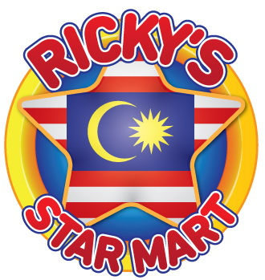

(1888 PressRelease) RICKY'S STAR MART; A Unique MiniMart Concept to File Trademark Registration In Malaysia (Trademark Name + Logo).

RICKY'S STAR MART is owned and created solely by Ricky Ahluwalia.
Ricky is born in Jakarta, Indonesia on the Thirteenth of March Nineteen Seventy Six (13.03.1976).
Ricky is married since 2006 and is blessed as a father of two.
On this date, 13th April 2013, Ricky has moved to register Trademark for RICKY'S STAR MART in Malaysia, and plans to start operation in 2014-2015.
RICKY'S STAR MART is a MiniMart concept that shall go beyond personal interest toward a broad goal to contribute toward society as a whole, by taking a certain percentage out of the nett profits to contibute toward a positive impact for Malaysia.
Therefore, all who shall be loyal customers of RICKY'S STAR MART is a star, as he/she will be a part of this positive movement.

###

