Restoration Environmental Launches New Web Site: www.rechazmat.com and offers Ontario Emergency Response Call Center for Disasters, Removal of Asbestos and Hazardous Materials
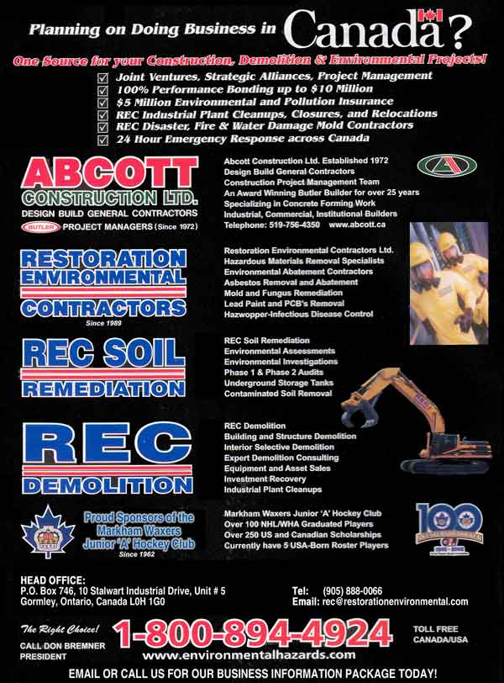

(1888PressRelease) Restoration Environmental offers immediate Hazardous Materials emergency response services for disasters, asbestos removal as well as fire, wind and flood water damage. The Call Centre assists our 600 clients in Toronto GTA and across Ontario in industrial, commercial, institutional, government, hospitals, school boards, and pharmaceutical. 1.800.894.4924 www.rechazmat.com
(1888PressRelease) - Toronto, Ontario, Canada: Restoration Environmental Contractors REC Announces New Website Launch www.rechazmat.com and the New Ontario Hazardous Materials HazMat Environmental Emergency Response Call Centre for Environmental and Water Damage Disaster Emergencies!
The Ontario Emergency Response Call Center is 1.800.894.4924. Website: http://www.rechazmat.com
Restoration Environmental offers immediate HazMat emergency response services for disasters, asbestos removal as well as fire, wind and flood water damage. It assists our clients in Toronto GTA and across Ontario in the following industries: commercial, institutional, government, hospitals, and school boards, pharmaceutical and petrochemical.
Restoration Environmental REC Disaster Recovery the REC Emergency Response Team, a leading full service turnkey environmental remediation, HAZMAT hazardous materials removal and water damage restoration contractor operating throughout Ontario, Canada, today announced that it has based a Hazardous Materials Environmental Emergency Response Call Center here to respond to all natural disasters, hazardous materials, environmental and flood water emergencies throughout the Toronto, the GTA and Province Ontario including Golden Horseshoe region.
The facility also augments the company's hazmat environmental cleanup and water damage restoration business and logistical support services for the region, as well as supports existing environmental field services for Toronto, GTA and the Province of Ontario.
REC has serviced over 600 customers province wide, including a many of the Fortune 500 companies, hundreds' of smaller private corporate entities and numerous federal, provincial, city, regional and local governmental agencies and facilities.
"Restoration Environmental REC Emergency Response every week routinely and confidentially responds to HazMat environmental, asbestos, mold and/or water damage emergencies across the GTA, Toronto and Ontario," said Don Bremner, Senior Project Manager and CEO, of REC Site Services. "Our customers recognize that REC provides a Police Checked HazMat Staff and highly trained in HazMat Response Team Health and Safety.
"That is the priority, we have tremendous amount of expertise and experience with over 11,000 projects completed and one million hours of onsite project management experience and a substantial customer base in Toronto, the GTA and the Province of Ontario". "
"The Markham Stouffville facility gives us the ability to respond much more quickly to natural disasters, commercial and industrial emergencies anywhere in the region with all the HAZMAT equipment, supplies and experienced personnel to minimize the environmental or hazardous materials impacts of flood, fire, wind, and water damage or any disaster."
REC is an approved Pre-Qualified Federal Canadian Government and Ontario Government Contractor for SECURE FACILITIES: Restoration Environmental specializes in working in Facilities with a high level of Security, with all our Staff being CPIC Checked, Approved and Certified by the Ontario Provincial Police, York Regional Police and/or & Metro Toronto Police.
The Ontario emergency response call center is a staging area and warehouse for resources and supplies that enables Restoration Environmental REC Disaster and the REC Emergency Response Teams' highly trained personnel to quickly respond to all clients' building-based emergencies at industrial, commercial, institutional, government and chemical facilities, as well as hospitals, school boards, storage and transportation facilities.
Restoration Environmental REC Disaster Recovery the REC Emergency Response Team announced that it has based a new regional emergency response call center to respond to all Hazardous Materials environmental emergencies throughout Ontario.
Restoration Environmental Offers immediate regional emergency response service for asbestos removal, flood water damage to all industrial, commercial, institutional, government hospitals, school boards, pharmaceutical and petrochemical industry in Toronto GTA and across Ontario, Call Centre 1.800.894.4924
REC is The Right Choice - Ready with Highly Prepared and Trained, Health and Safety is the priority and Staged for Immediate Deployment to your site.
The Restoration Environmental facility houses specialized HEPA Equipment for Removal of all HAZARDOUS MATERIALS and environmental abatement, restoration and remediationWater Flood Damage equipment, material supply and trucks, personal protective equipment, Mobile Decontamination Trailers, mobile communications equipment and other response assets are also kept at the ready. All environmental and restoration equipment, including fully outfitted trucks and supplies are stored on trailers, HazMat trucks or packaged for immediate deployment anywhere in the Toronto the GTA and Province of Ontario.
The Ontario emergency response call center joins Restoration Environmental's extensive network of environmental service team providers, equipment and material suppliers and sub-trade contractor network that provide local environmental and water damage restoration cleanup capabilities throughout Toronto, the GTA and Province of Ontario.
All Restoration Environmental response resources are available to its all its customers through a local and Ontario Emergency call center at l.800.894.4924 Canada / USA.
About Restoration Environmental REC Disaster Recovery REC Emergency Response
Since 1989, Restoration Environmental REC Emergency Response Service is one of Canada's leading environmental service contractors specializing in asbestos removal, lead abatement, mould remediation, hazardous materials removal and environmental cleanup, water damage restoration, plant decommissioning, soil and site remediation and demolition for ICI Sector, industrial, commercial institutional and government.
Restoration Environmental One of Canada's most respected Environmental
Remediation and Demolition Companies at The Guild Inn, Scarborough, The Philips Cable Plant Brockville and Regent Park in Toronto
Here's the link on YouTube The Guild Inn Abatement & Demolition
http://www.youtube.com/watch?v=qX4pMe-YuLA
Here's the link on YouTube Restoration Environmental
Toronto Asbestos Removal in Toronto 1998
www.youtube.com/watch?v=dQnHhbM_MoA
YOUTUBE Restoration Environmental REC Demolition VIDEOS BY OTHERS:
REGENT PARK Toronto Demolition LEED Project
http://www.youtube.com/watch?v=B-D1nc_CGmo
500,000 sq. ft. Brockville Chimney Stack Demolition Phillips Cable
http://www.youtube.com/watch?v=2SNalTUuxEE
The Guild Inn Historic 7 Storey Demolition City of Toronto
http://www.youtube.com/watch?v=qX4pMe-YuLA
Headquartered in Gormley, (Stouffville/Markham), Ontario, Canada: Restoration Environmental REC Emergency Response Service has successfully completed over 11,000 projects and provides its' specialized environmental services to ICI Institutional Commercial Industrial Sectors, DND, the City of Toronto, Canadian Government and Ontario Government facilities throughout the province.
The Company also operates under REC Disaster Recovery, REC Emergency Response Service, REC Demolition.
Restoration Environmental Builds Strong Partnerships with its' customers, and welcomes Strategic Alliances, Joint Ventures with Architects, Engineers, Consultants and Building Facility Owners.
For more information, visit http://www.environmentalhazards.com or http://www.recdisaster.com
New Web Site:http://www.rechazmat.com
Email: rec ( @ ) restorationenvironmental dot com
Contact Don Bremner 1.800.894.4924
Trackback Url :
http://www.1888pressrelease.com/hazmat-services/hazardous-materials/restoration-environmental-launches-new-web-site-www-rechazm-pr-379960.html
###

