World's first hydrogen fuel produced using scrap material

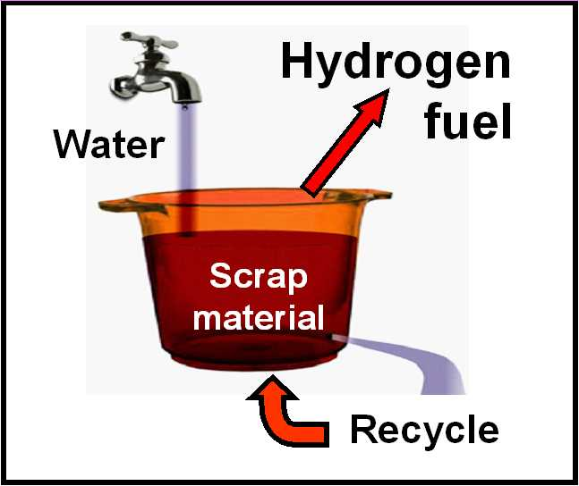

(1888PressRelease) Hydrogen-on-demand produced using only water, paper and scrap aluminum

Tulsa, OK - More than 35 gallons per minute of hydrogen was recently produced using only water, paper and scrap aluminum. This rate of hydrogen production was sustained with no energy being added to the system after the water was heated . "35 gallons per minute is only the starting point," said a spokesman. "The production rate can be increased to any desired level of production, up to thousands of gallons per minute of hydrogen."
This simple technology represents an alternative-fuel leap forward because, in the past, higher levels of hydrogen gas production have required a proportional increase in input energy for previous methods of hydrogen generation. The new breakthrough solves this drawback, common for all existing hydrogen production methods, including all electrolysis and thermochemical methods. The new breakthrough is based on the discovery and development of a process that uses only scrap materials and increases the output of hydrogen without requiring increasing energy to drive the system.
The cost advantage for this simple technology requires only scrap metal and water for fuel. The new method of hydrogen production uses a catalyst that can be produced from scrap paper.
Yes, it is that simple -- A new material has been produced that makes hydrogen when it is added to warm water. The new material was produced in a research program to find a new and better way to produce hydrogen-on-demand for use as a cost-saving supplemental fuel for engines that burn petroleum. The new material, called Catalyzed Aluminum (CA) combines scrap aluminum with a new water-splitting catalyst to produce hydrogen.
Fuel cost saving is the reason for using CA to produce hydrogen as a fuel supplement. 32% to 40% increases in miles per gallon have been demonstrated by simply adding a small amount of hydrogen to the air used by an automobile engine. One pint of the CA material produces hydrogen at a flow rate that is higher than that required to increase the MPG of an automobile by more than 30%.
Hydrogen fuel storage tanks are no longer needed because of this new low-cost, safe method for producing hydrogen fuel at high flow rates using a mixture of aluminum and carbon, two of the world's safest and lowest-cost industrial materials. The hydrogen-from-water breakthrough was a result of a catalytic chemistry development that successfully splits water to produce hydrogen, while retaining oxygen in the water. That breakthrough was rapidly used to develop CA which is a mixture of aluminum and catalytic carbon, a material optimized to generate hydrogen by simply adding warm water to the CA material.
For many years, experts have agreed that hydrogen will command a key role in future renewable energy when a relatively cheap, safe, efficient and non-polluting means of producing hydrogen can be developed, on demand, at very high rates which make hydrogen storage tanks unnecessary. That goal has been met, for the first time, using the new CA process.
Before this new process was developed, the use of hydrogen fuel was limited by the lack of an inexpensive catalyst that can speed up the generation of hydrogen from water. A vital part of the CA development success was combining predictive theoretical chemistry and verification testing to accelerate the process of identifying catalytic carbon as a new catalyst for use with aluminum to split water and obtain hydrogen.
Bion Energy, Ltd. is Phillips Company's strategic alliance and authorized agent in England. The Bion Energy organization is seeking global partners for the roll-out and application of this technology; particularly in the Caribbean, Africa, Middle East and South America. Please contact Fred Davey, Bion Energy at Fred.davey ( @ ) bionenergy dot co dot uk
Catalyzed Aluminum (CA is now available for commercialization of systems that will use hydrogen for fuel supplements. The catalytic process can be licensed from Phillips Company. The licensing agent is the patent attorney for Phillips Company; Mr. A. Shravah; Email: ashravah ( @ ) gmail dot com
The CA process for producing hydrogen from water is described online at www.PhillipsCompany.4T.com/CA.pdf
Samples of the new material are available from Phillips Company; Email: hp ( @ ) valliant dot net
http://www.PhillipsCompany.4T.com

###

