Professional Chiropractic Consultants Launch World Class Caribbean Adventure Mastermind
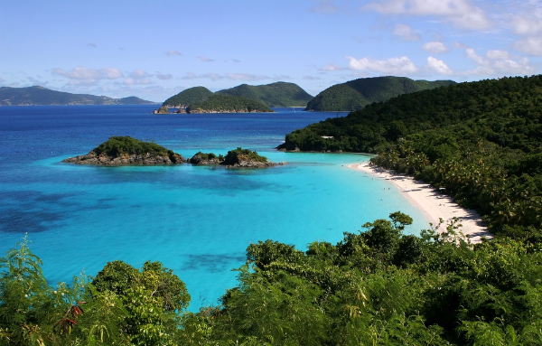

(1888PressRelease) Dr. Mike Reid and Dr. Matthew Loop have recently announced the launch of The Ultimate Caribbean Adventure Mastermind for chiropractors! The high achieving, top caliber doctors this exclusive experience is attracting is simply incredible and the buzz the event has garnered in such a short time is unbelievable.
(1888PressRelease) - Seasoned chiropractic marketing coaches, Dr. Mike Reid and Dr. Matthew Loop, recently launched The ultimate Caribbean Adventure Mastermind for chiropractors. There has never been anything like this offered for chiropractors, especially in an exquisite Caribbean paradise like Turks and Caicos.
This highly anticipated event is set to take place on April 20th through April 22nd.
From his office in Atlanta, Dr. Loop says "Most chiropractic seminars are lame, boring, and in an over-hyped or dull location.. I don't mean to step on any toes but it's the truth. What Dr. Mike and I have put together is unrivaled, as far as chiropractic events are concerned. Not only are we going to show fellow chiropractors how to systematically build a million dollar practice (from docs that have actually done it), but we're going to show them how to turn the internet and social media into a ATM that pays healthy 5 figure passive income streams for life."
Loop goes on, "And, if that wasn't enough to get doctors excited, we have so many cool, unforgettable excursions planed like snorkeling, horseback Riding, ATV-ing, Eco Kayaking, scuba diving, deep sea fishing, private dinners on the beach, a welcome BBQ, and much more!"
Chiropractors whose applications are accepted for the mastermind will discover:
1) How to Finally Turn Social Media into a Practice Cash Machine
2) World's Top 10 Websites And Design Elements To Generate an Extra 15-20 New Patients Per Month with hardly any work
3) How to create 5 figure / month passive income streams online (on top of your Chiropractic practice) that pay you for life!
4) How To Create Your Purple Cow: Standing Out And Dominating The Competitive Marketplace
5) How To Design Organize And Execute Your 12 Month Marketing Calendar For 60-100 New Patients Per Month!
6) How to build an unstoppable, systematic, profit pulling, internet marketing funnel that positions you as the "go-to" chiropractor in your city.
7) Master The Top 12 Tools That Are Exploding Todays' Practices For Total Market Dominance
8) How to turn what you already know into a vast array of information products that sell for high prices online. (Dr. Loop's 7 Figure Rolodex included).
This highly unique retreat is limited to the first 25 successful applicants that qualify. At the moment, there are 15 spots left. The Turks and Caicos event is only for those chiropractors who:
- Are committed to living an extraordinary life on their terms.
- Have a taste for the finer things in life and enjoy uniqueness.
- Crave more millionaire connections and like to network with the top 1% of chiropractors and industry heavy-weights.
- Have a desire to participate in exotic, unforgettable adventures on a secluded, world-class beach.
- Are self-motivated, resourceful, fast to implement, and always go in the opposite direction of the masses.
- Like the idea of making more, experiencing more, and giving more.
- Prefer short-cuts that accelerate, efficiently maximize, and multiply your success.
Join Dr. Mike Reid and Dr. Matthew Loop and an extraordinary group of entrepreneurial doctors who are committed to creating massive results in practice, on the internet, and in life. For more specifics on this private event and to apply, call 1-800-781-8127 or visit the website below to see if you qualify
http://myemail.constantcontact.com/Build-Your-Practice-and-Web-Presence-From-The-BEACH-.html?soid=1102293795672&aid=A34bqYW-9Mg
If you're ready for a fun, world-class experience that provides tangible benefits and generates you substantially more PASSIVE income for the rest of your life, complete the application today! Again, the event happens on April 20th through April 22nd. Call call 1-800-781-8127 and secure your spot before the event sells-out.
http://dcincome.com/blog/the-ultimate-caribbean-adventure-mastermind-for-chiropractors/
Trackback Url :
http://www.1888pressrelease.com/professional-chiropractic-consultants-launch-world-class-car-pr-380338.html
###

