Pan American Metals of Miami Announces Addition of Numismatics Division
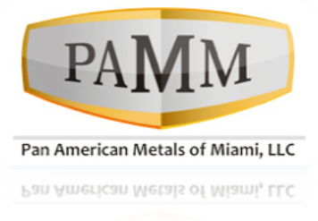
(1888PressRelease) Pan American Metals of Miami is leading the way for investors to take advantage of the investment opportunities in precious metals.
(1888PressRelease) June 30, 2010 - Miami, Florida; June 30, 2010 - Pan American Metals of Miami is excited to announce that as of July 1, 2010 they will be opening a numismatics division to address the ever increasing demands of its clients to provide rare coins and physical metal. Pan American Metals is looking for a precious metals broker to spearhead this division and to leverage their years of experience to enhance the overall business model.
Pan American Metals of Miami is leading the way for investors to take advantage of the investment opportunities in precious metals. Precious metals or bullion holdings have an intrinsic value that provides a level of investment security not found in most other financial instruments. The seasoned staff of Pan American Metals of Miami can help both individual and institutional investors capitalize on the current market conditions. About the new numismatics division Pan American Metals says, "We are excited about this opportunity and feel it will enhance our business model and customers experience.
Precious metals include gold, silver, platinum and palladium. Also referred to as precious metals bullion, this is a truly unique financial instrument. Investors are not purchasing the right to buy or sell (such as grains futures), guessing on a price (equities options), or depending on the health of a company (listed stocks). Rather, they are purchasing a true physical holding in a precious metal. For thousands of years metals have been treasured due to their rareness and functionality. This means an investor is purchasing a position in an item that has held the test of time.
About Pan American Metals
Pan American Precious Metals of Miami is a privately held corporation based in Miami, FL. PAPMOM specializes in precious metals investments offering both fully-funded and leveraged positions. PAPMOM investors have the option to have their investment physically delivered to them or held in a security repository for safe keeping. Pan American Precious Metals of Miami is made up of a veteran group of traders, investors and brokers that offer investors solid insight into the world of precious metals bullion. The management team has over 100 years of experience in precious metals investments. "Our philosophy is that our traders only suggest positions, which the traders themselves would be comfortable holding".
For additional information contact:
Debbie Bailey
Pan American Metals
305-532-4112
235 Lincoln Rd. Miami Beach, FL 33139
invest ( @ ) investpanam dot com
Trackback URL:
http://www.1888pressrelease.com/pan-american-metals-miami/precious-metals/pan-american-metals-of-miami-announces-addition-of-numismati-pr-221850.html
###

