MrsP.com Announces Winners of 2nd National Kids' Writing Contest
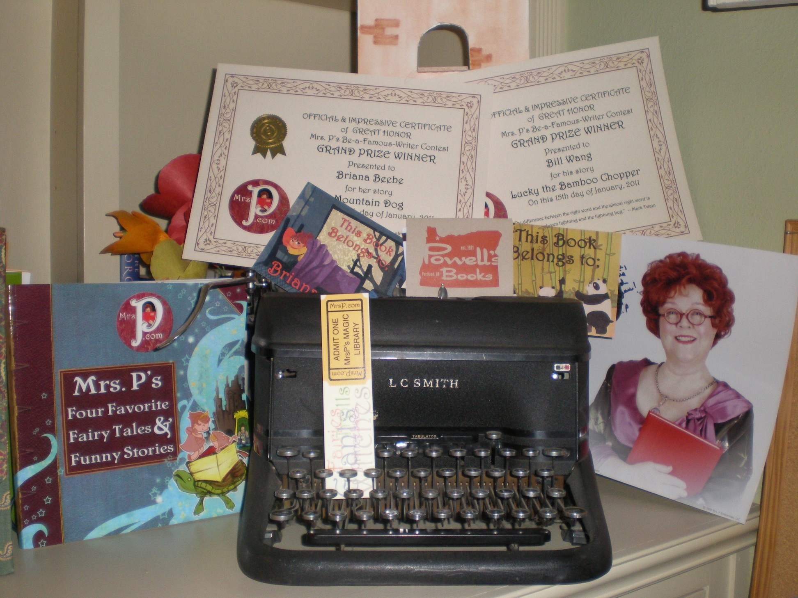
(1888PressRelease) Young authors from Colorado and Oregon chosen over writers from 26 states by celebrity judges in Be-A-Famous Writer Contest.
(1888PressRelease) - MrsP.com announced today the names of the two Grand Prize winners in its second "Be a Famous Writer" contest, a nationwide creative-writing competition for children held every September.
Briana Beebe, 8, of Centennial, Colorado, won top honors in the 4- to 8-year-old category for "Mountain Dog," the story of a beloved pet that disappears during a family's move to a new home. Bill Wang, 12, from West Linn, Oregon, won in the 9-13 age group for "Lucky the Bamboo Chopper," the fable of a young panda bear who learns an important life lesson.
"I was thrilled with the entries this year, which came in from 26 states - more than half the country," said TV star Kathy Kinney, who portrays Mrs. P and is one of the creators of the website. "I was also very happy about the number of teachers who used the writing contest as a class project. Encouraging one child to write an original story is wonderful. Encouraging 30 is absolutely amazing."
The Grand Prize winners will have their stories produced as videos featuring Mrs. P, which will be presented on her popular free, interactive digital website. Original artwork by award-winning Portland, Oregon-based illustrator Robin E. Kaplan will help bring the stories to life. The videos will be posted on the website (www.MrsP.com) beginning in March. Each winner will also receive an actual bound copy of the story and illustrations.
Powell's Books (www.Powells.com), the country's largest independent bookseller and the sponsor of the contest, will provide the Grand Prize winners and eight other finalists with gift certificates to its store. The stories will also be available as a free download bundle from iTunes on March 2nd in celebration of Read Across America Day.
MrsP.com announced that it will produce two other stories from the contest as videos: "The Peanut Butter and Jelly Hotdog," written by a 5-year-old and chosen because of its clever and compassionate look at grade-school bullies; and "Ramona and the Fire," honored for its amusing twist on "The Boy Who Cried Wolf" fable.
The judges for this year's contest included some of the world's most famous writers: #1 best-selling author Meg Cabot ("The Princess Diaries"); Jim Davis, creator of Garfield, the most popular cartoon strip in the world; and Danny Kallis, creator of the Disney Channel's "The Suite Life of Zack and Cody" and "The Suite Life on Deck," television's top-rated shows for kids.
MrsP.com was launched in 2008 to encourage a love of reading. The website is the recipient of the American Library Association's "Great Website for Kids."
Trackback URL:
http://www.1888pressrelease.com/mrsp-kathy-kinney/fun-activities/mrsp-com-announces-winners-of-2nd-national-kids-writing-con-pr-270870.html
###

