January 2013 is National Radon Action Month in U.S.A. | Take Action Against America's Leading Household Killer! SWAT Environmental is Saving Lives.

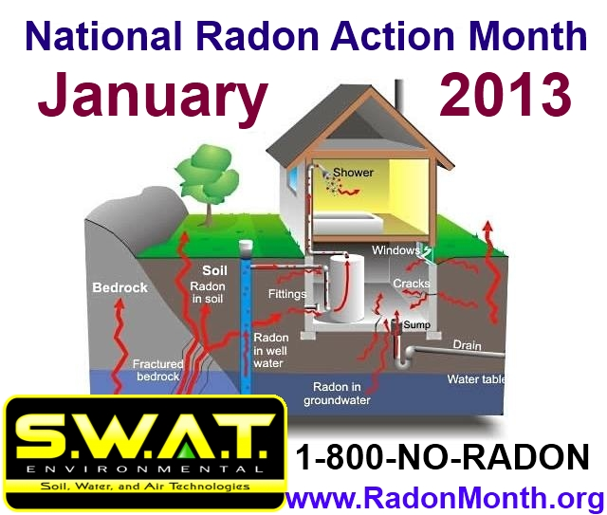

(1888PressRelease) The Surgeon General of The United States is urging home and business owners to test for this deadly gas. Radon levels are typically higher in the winter months and the threat may be at its greatest in January. For this reason, Environmental Protection Agency is designating January 2013 as National Radon Month. For more information, contact S.W.A.T. Environmental at 1-800-NO-RADON.

Lexington, KY - Many people probably have barely even heard of radon; much less know it has earned its own awareness initiative, National Radon Action Month. Radon is an invisible, tasteless, odorless gas capable of unexpectedly leaking into your home. Each year, despite the attempts of concerned individuals during National Radon Month, radon claims the lives of thousands. It is the second leading source of fatal lung cancer because it results from natural causes and can ail literally any building. As such, the EPA has delegated January as National Radon Month.
According to James Gelina, a radon mitigation specialist from S.W.A.T. Environmental, "radon causes more in-home deaths each year than carbon monoxide and fires combined." During National Radon Awareness Month, it is important to raise awareness regarding the deadly risks involved in not having a location tested for radon infiltration. These tests are cheap, simple, and not time consuming so, even if you reside in a building boasting radon-resistant features, take some time during National Radon Month to gain some peace of mind.
Another goal of National Radon Action Month is to banish ill-informed myths regarding the origins of the compound. While other leaks and problems may arise from faulty pipes or improperly installed systems, radon is a result of the natural breakdown and decay of uranium that occurs in most soils. In some cases, radon can even emanate from various building materials so spend this National Radon Month ensuring your home and workplace is safe. "When elevated radon levels are detected, we can put affordable remedies in place to permanently correct the issue," states Mr. Gelina. His firm, SWAT Environmental is the largest radon mitigation company in North America and installs over 10,000 of these "radon remediation" systems each year.
Nearly 7% of American homes are estimated to have elevated levels of radon and these are the people being targeted in National Radon Month. Some of the methods radon uses to enter your home may include cracks in floors and walls, gaps around service pipes or in suspended floors, cavities inside of walls, or even with the water supply.
During National Radon Awareness Month, every household should be conducting at least short term tests for radon levels. There are a variety of methods to choose from in conducting these smaller scale tests but if they display a reading of 4, further testing is required. While the mere 31 days of National Radon Month cannot provide ample evidence of the presence or absence of a radon leak completely, it should supply sufficient cause for either more or less extensive testing. National Radon Month is used to gather a reliable sample to represent data apparent all year round.
Another fact worth investigating during National Radon Action Month is whether your water is supplied from surface water or ground water. Surface water poses much less of a threat than ground water, whether it stems from a private well or public supply. National Radon Month is an excellent opportunity for you to pressure your water supplier into having their reserves checked and tested for radon leaks.
National Radon Awareness Month is also a time for correcting the problems noticed. Sealing cracks in foundations can be effective but the best way to celebrate National Radon Month is to install a vent fan system that will draw unwanted radon gas from the house. Contact a local specialist and inquire if they offer any National Radon Month discounts or promotions. Don't live under the risk of radon any longer than you have to and get tested this National Radon Action Month.
During National Radon Month, S.W.A.T. Environmental, The largest radon company in the United States, is offering special discounts on radon reduction and radon testing options. $100 radon abatement vouchers are being issued to business and homeowners in the following states: Colorado, Missouri, Kansas, Minnesota, Wisconsin, Indiana, Michigan, Kentucky, Alabama, Tennessee, North Carolina, South Carolina, Georgia, Maryland, Virginia, West Virginia, Pennsylvania, Delaware, Connecticut, New York, Massachusetts, New Hampshire, and Rhode Island. For more information, call 1-800-NO-RADON or visit http://www.RadonMonth.org

###

