Protera Technologies Now an SAP-certified Provider of Mobile Operations
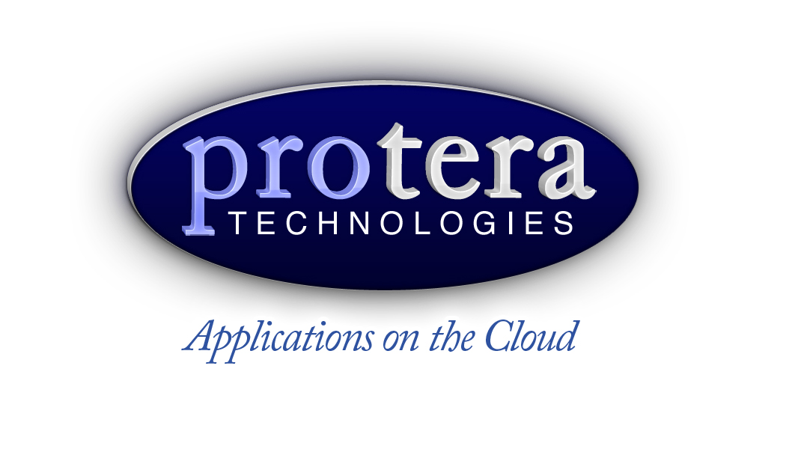

1888 PressRelease - Protera has received certification from SAP for its ability to deliver mobile operations services for SAP software with high-quality operational standards.

Westchester, IL - Protera Technologies (http://www.protera.biz), Inc., a leader in managed global IT platforms for enterprise applications and an SAP-certified provider of hosting and application management services, today announced it has been certified by SAP as a provider of mobile operations for SAP® solutions.

The mobile operations services offered by Protera Technologies are delivered as a fully managed platform run in secure data centers and on cloud services. Users gain the flexibility to securely access and interact with their SAP application from mobile devices such as smart phones and tablet computers. Protera's mobile operations services are available on demand and include 24/7 operation support and operation management services. Organizations can deploy Protera's mobility services for SAP applications on a monthly basis for a services fee without having to invest upfront in additional IT infrastructure and resources.

"We are pleased to have worked with SAP on completing this certification process, which validates our ability to deliver mobile operations services for SAP software with high-quality operational standards," commented Dean Adamopoulos, CEO, Protera Technologies. "Our customers will gain the benefit of on-demand and easy-to-deploy mobility services to accelerate the success of the mobility initiatives based on SAP solutions."

To ensure ongoing high standards for the management of SAP solutions, certified providers undergo a rigorous assessment of their delivery and support capabilities every two years by SAP's outsourcing partner engagement group.

About Protera Technologies
Protera Technologies, Inc., a global total IT outsourcing services provider, was formed in the mid 90s to provide comprehensive end-to-end IT solutions for customers. Protera Technologies has capitalized on its strong expertise with SAP solutions to evolve into a pioneer of end-to-end total IT outsourcing global solutions that cover all IT needs of an organization. Protera has built an on-demand operations platform - AppCare - to deliver total IT outsourcing services.

The AppCare platform brings together the comprehensiveness of a total IT solution along with the flexibility, robustness and cost effectiveness of on-demand/cloud innovations. Protera's services focus on total customer satisfaction with dedicated points of contact and experts that know customers' environments in depth.

SAP and all SAP logos are trademarks or registered trademarks of SAP AG in Germany and in several other countries.
All other product and service names mentioned are the trademarks of their respective companies.

For More Information, Press Only:

Christian Wissmann
Office: +1 240.284.4363
Email: c.wissmann ( @ ) protera dot biz

###

