Hydrogen Fuel Produced At Lowest Cost Using New Catalyst

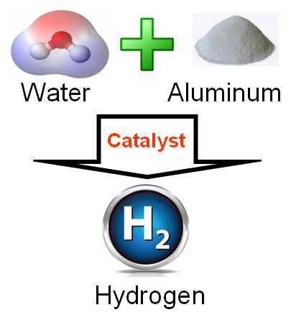

(1888PressRelease) For the first time in history, hydrogen fuel can produce more energy during combustion than the energy used to extract the hydrogen from water.
(1888PressRelease) New York, NY - Hydrogen fuel can be produced at lower costs and at higher rates than ever before using a new catalyst. Catalytic carbon, manufactured using a new activation process, extracts hydrogen from water more efficiently than any other method. Hydrogen fuel can be produced at lower costs and at higher rates than ever before using this new catalyst.
The unique thing about this new process is that it requires no power input after the hydrogen-producing reaction is started using thermodynamic equilibrium design of the hydrogen-producing cell. For the first time in history, this new process allows the scale-up to high rates of hydrogen on demand (HOD). This means that hydrogen storage tanks are not required to meet high-volume fuel requirements.
Because the process does not use electricity and does not require energy input after the hydrogen production is started under thermodymic equilibrium, this new method can be scaled up to produce hydrogen fuel cheaply for any application.
Experts agree that hydrogen will command a key role in future renewable energy now that hydrogen fuel can be produced, on demand, at very high rates which makes hydrogen storage tanks unnecessary.
Hydrogen is an energy dense and clean fuel. Upon combustion, hydrogen releases only water vapor. Historically, most hydrogen was produced from electrolysis which requires large amounts of electrical energy or from natural gas which results in excessive carbon-dioxide emissions. An alternative, clean method is to make hydrogen from water using carbon. The new process is called CC-HOD, or Catalytic Carbon, Hydrogen on Demand.
Using hydrogen to fuel ships is promising because this new process works well with sea water. Low-cost hydrogen can be used to fuel electric power generators on islands or in remote locations where water is plentiful and cheap, compared to the cost of importing oil/diesel via tanker ships.
In the recent State of The Union address, the President said, "This country needs an all-out, all-of-the-above strategy that develops every available source of American energy - a strategy that's cleaner, cheaper, and full of new jobs." Most Americans agree.
Phillips Company is looking to license the technology and Intellectual Property. "We are searching for companies that want to commercialize low-cost hydrogen fuel. We have the catalytic chemistry that provides for the HOD technology, and we are in discussions with companies who want to revolutionize the world by developing and implementing our novel HOD technology for its various potential applications. We envision a hydrogen economy where gasoline for vehicles, planes and ships will be replaced by hydrogen fuel, as well as power generation and heating for homes and buildings," said Aasheesh Shravah, the licensing agent for Philllips Company. He can be reached by email at ashravah ( @ ) gmail dot com dot
This new hydrogen fuel process is described on-line at
www.PhillipsCompany.4T.com/HYDROGEN.html
Trackback Url :
http://www.1888pressrelease.com/hydrogen-fuel-produced-at-lowest-cost-using-new-catalyst-pr-379909.html
###

