Corcentric Announces New Webinar On Accounts Payable Automation

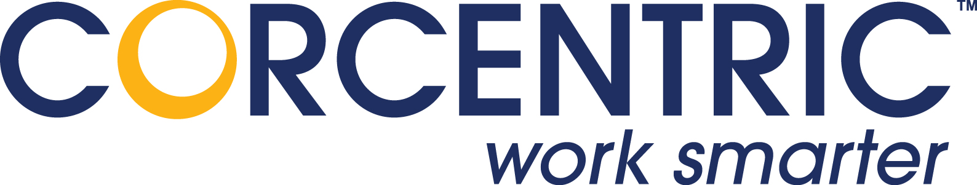

(1888PressRelease) Webinar Uncovers the Automation Gaps that Occur in the AP Process and Explores Solutions.
(1888PressRelease) - McLean, VA - Corcentric, a leading provider of accounts payable automation solutions, today announced a new live Webinar: How Do You Achieve Accounts Payable Automation Using Software as a Service? The 45- minute Webinar, which is the first in a series of educational Webinars about AP automation, takes place on Thursday, October 7th at 2:00 PM EDT.
Rob DeVincent, Vice President of Corcentric Product Marketing is the Webinar's featured speaker. He will explore how enterprises have been attempting to bridge the automation gaps that persist in the back office where people, paper, and process collide. He will then explain how to seamlessly link Accounts Payable through automated solutions like ZeroTouch invoice handing and Straight Through Processing. In addition, he will show how AP Departments can dramatically improve operations and drive out costs using a Software-as-a-Service model.
"We are excited about this new Webinar and plan on introducing a new educational series for Accounts Payable professionals. By attending this event, they'll discover how companies can combine industry best practices with AP imaging and workflow, achieve the benefits of Straight Through Processing, and manage exceptions when invoices do not match. They'll also find out how to develop approval workflow using Delegation of Authority rules, interface with their ERP system using Business Connectors, and analyze and monitor workflow activity," stated Mr. DeVincent.
AP automation is a critical topic because of the pressure companies are under to reduce costs and improve processes. A complete solution that incorporates invoice imaging and workflow automation offers up to a 90% reduction of costs according to the Aberdeen Group. This results in stronger internal controls, and the overall streamlining of the AP invoice review and approval process.

For additional information and to register for the Webinar, please click here http://www.corcentric.com/.
Trackback URL:
http://www.1888pressrelease.com/ap-automation/erp/corcentric-announces-new-webinar-on-accounts-payable-automat-pr-245892.html
###

