Name of Game | Memory Game - Catch A Toy
Email | mary@rvappstudios.com
Publisher | RV AppStudios
Summary Description | Catch A Toy is a simple yet addictive fun puzzle memory game. Increase your short term memory with fun & challenging levels with competitive timing and difficulties.
Size (MB) | 13MB
Version | 1.0
App/Game Category | Games
App/Game URL | http://www.barnesandnoble.com/w/memory-game-rv-appstudios/1114668050
Game Logo | 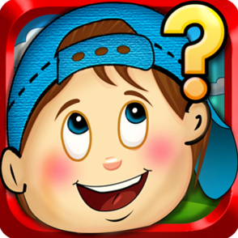
Price | $0.99
Languages | English
Release Date | 20/02/13
Full Description | Catch A Toy is a simple yet addictive fun puzzle memory game. Increase your short term memory with fun & challenging levels with competitive timing and difficulties.  Simply tap & select an object and then open another object to match. Levels are divided in 3 different Grades to increase difficulty gradually. Multiple levels in eye catchy backgrounds provide excitement to keep your kids busy, and moreover it's fun for all ages.  Sharp memory and quick response to match similar object is the key to winning.
Screen Shots | 