The American Society Of Bariatric Plastic Surgeons Website Expands
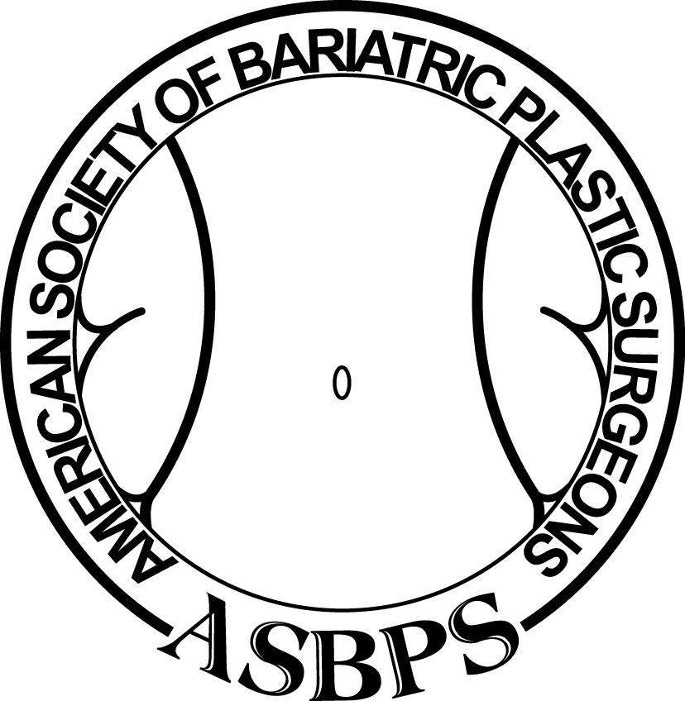
(1888PressRelease) The American Society of Plastic Surgeons website now features more information for bariatric patients seeking to reconstruct their face and bodies after excess weight loss as a result of bariatric surgery. Extensive library of before and after photographs of members' patients are included as well as the ability to ask plastic surgeons about their specific problems.
(1888PressRelease) - ASBPS.org continues to expand with more information about procedures available and photographs of patients before and after undergoing face and body contouring operations.
Obesity has achieved epidemic proportions in the United States. "According to the Centers for Disease Control and Prevention, the prevalence of obesity in America has increased from 40% to 70% in the past 20 years.
Bariatric gastric bypass surgery is becoming an acceptable and effective means of weight loss and of alleviating its associated medical issues like diabetes, blood pressure and cardiac problems. According to the American Society of Bariatric & Metabolic Surgery, 220,000 people with morbid obesity in the U.S. had bariatric surgery in 2009 which has increased dramatically.
An increased number of these patients are undergoing corrective plastic surgery to remove the excess skin resulting from their weight loss. According to the statistics of the American Society of Plastic Surgeons, lower body lift and upper arm lifts have increased by about 4000% in the nine year period from 2000-2009.
"The American Society of Bariatric Plastic Surgeons continues in the forefront of educating bariatric patients in what procedures are available for those seeking to complete their weight loss journey through various face and body contouring procedures," said its President, Dr. Ed Domanskis. "Our website has been enhanced with more information and realistic photographs provided by our member plastic surgeons."
The American Society of Bariatric Plastic Surgeons was established by plastic surgeons that specialize in body contouring surgery specifically for patients that have lost significant amounts of weight through non-surgical means such as diet or exercise or through the various bariatric procedures. ASBPS's goal is to help find a knowledgeable and experienced plastic surgeon. Its members are all certified by the American Board of Plastic Surgeons and most are members of the American Society of Plastic Surgeons as well as the American Society of Aesthetic Plastic Surgery or the Canadian Society of Plastic Surgeons.
Trackback URL:
http://www.1888pressrelease.com/bariatric-plastic-surgery/bariatric-plastic-surgeon/the-american-society-of-bariatric-plastic-surgeons-website-e-pr-248495.html
###

