SkinGenX Launches its Monthly Giveaway Program
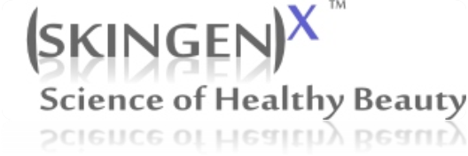
(1888PressRelease) Each month SkinGenX will send a free bottle of its new product, Anti-Wrinkle CompleX along with a 100% natural and handmade silk scarf from Turkey to the giveaway winners.
(1888PressRelease) July 07, 2010 - To enter, contestants should go to http://skingenx.com/giveaways and fill out the form on this page along with their questions, comments or how they think this product would help them with their skin concerns. At the end of each month, one winner will be chosen. The terms and conditions of the program can be found at the bottom of the same page.
Company founder and president Aybegum Senkesen said "We are humbled by the positive feedback our products have received since our launch less than a year ago. We believe in social responsibility and have made it our mission to provide eco-friendly, safe and sustainable products that also help economically disadvantaged communities all around the world. We started an Empowerment Project with rural artisans in Turkey who hand paint beautiful, 100% natural silk scarves for SkinGenX. Retail value of these scarves would be over $50 each. We will send these to our first time customers and our giveaway program winners."
About SkinGenX
SkinGenX was founded by Aybegum Senkesen, a chemist mom and a healthcare consultant with over a decade of pharmaceutical research experience along with her team of skin care experts to provide powerful anti-aging and wrinkle reduction skin care products with advanced formulas and high quality ingredients that are clinically proven to be safe and effective.
As a safety promise to its customers, SkinGenX does not and will not use the following ingredients in its products:
· Animal derived ingredients
· Chemical sunscreens (no oxybenzone or its derivatives)
· PABA
· Parabens
· PEG
· Phthalates
· Synthetic fragrances
· And none of SkinGenX's products are animal tested
SkinGenX is a proud signer of Compact for Safe Cosmetics and PETA's Cruelty-Free Program. More information on the company and its products can be found at http://www.skingenx.com/
For additional information, contact SkinGenX Public Relations Department at 1-800-610-GENX (4369)
Trackback URL:
http://www.1888pressrelease.com/anti-aging-skin-care/safe-effective-skin-care/skingenx-launches-its-monthly-giveaway-program-pr-223130.html
###

