New Military Thriller Warpath Features Native American Culture and International Locations in Story of Two Orphaned Brothers
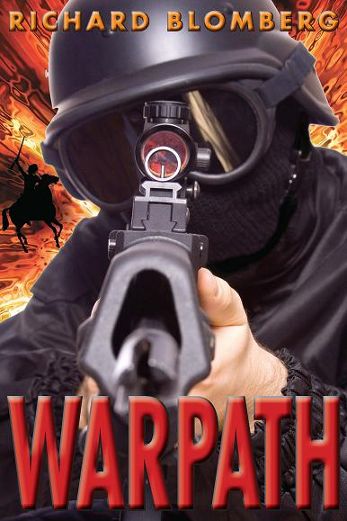

(1888PressRelease) Doctor Turned Author Richard Blomberg Draws on Knowledge of Military, Medicine and American Sioux Culture to Create Tale of Intrigue That Will Draw Readers In; Warpath Makes a Great Father's Day Gift.

Minneapolis-St. Paul, MN-WI - Today, author Richard Blomberg announces the release of his new military thriller, Warpath, the story of Jack Gunn, a Navy SEAL and American Sioux who combines 21st-century technology with 19th-century wisdom to track terrorists from Afghanistan to Pakistan to the Arabian Sea. The book would make an ideal gift for Father's Day, perhaps loaded onto a Kindle.
Warpath tells the tale of Jack Gunn and his brother, orphans who were raised by Sioux elders. One becomes a Navy SEAL, the other a doctor. Blomberg pulls from his intimate knowledge of the military, medicine and American Sioux culture in this fictional account that will have readers on the edge of their seats until the exciting conclusion.
The main character, Jack Gunn, has a rich Native American tradition and upbringing, a complicated relationship with his brother whom terrorists have kidnapped, and a gut-wrenching struggle to comfort his wife. With supreme effort, using fighting skills from another era, Jack leads his Ghost Team where no one else dares to go.
"I love over the top characters and the Gunn brothers fit the bill," commented an Amazon Breakthrough Novel Award reviewer. "I also really love the Native American spice thrown into this thriller. Great plot, easy reading, tight editing. What could be better!"
The book is the first in a series featuring Jack Gunn. For more about this fictional thriller, please visithttp://www.richardblomberg.com/. Warpath is available in ebook format from Amazon, BN.com, GoogleBooks, iBooks and SDPPublishing.com. Also visit and "Like" Warpath on Facebook.
About the Author
Dr. Richard Blomberg has practiced medicine in the land of 10,000 lakes for 20 years. He grew up in an Iowa farm town, the oldest of 10 kids, before serving as a Navy corpsman during the Vietnam War. For generations, Richard's family has proudly served in the Army, Navy, Air Force and Marines. Richard and his wife, Kim, have five wonderful children, and by the grace of God, are still deeply in love after 35 years of marriage. Kim's Nakota relatives fought at the Battle of the Greasy Grass (Little Big Horn.) Writing Warpath allows Richard to honor Native Americans and those who have served in the military by creating Jack Gunn, a Native American Navy SEAL extraordinaire. Warpath is his first thriller.

###

